**XJTLU Entrepreneur College (Taicang) Cover Sheet**

|  |  |  |
| --- | --- | --- |
| Module code and Title | **IOT103TC, ‘Computer Architecture and Operating System’** | |
| School Title | **School of Internet of Things, School of Artificial Intelligence and Advanced Computing.** | |
| Assignment Title | **Coursework** | |
| Submission Deadline | **6th Nov. 2020 (11.59 pm)** | |
| Final Word Count | **-** | |
| If you agree to let the university use your work anonymously for teaching and learning purposes, please type **“yes”** here. | | **YES** |

I certify that I have read and understood the University’s Policy for dealing with Plagiarism, Collusion and the Fabrication of Data (available on Learning Mall Online). With reference to this policy I certify that:

* My work does not contain any instances of plagiarism and/or collusion.  
  My work does not contain any fabricated data.

**By uploading my assignment onto Learning Mall Online, I formally declare that all of the above information is true to the best of my knowledge and belief.**

|  |  |  |  |  |  |  |
| --- | --- | --- | --- | --- | --- | --- |
| **Scoring – For Tutor Use** | | | | | | |
| **Student ID** | | | | **1930080** | | |
|  | | | | | | |
| **Stage of Marking** | | **Marker**  **Code** | **Learning Outcomes Achieved （F/P/M/D）**  **(please modify as appropriate)** | | | **Final**  **Score** |
| **A** | **B** | **C** |
| 1st Marker – red pen | |  |  |  |  |  |
| Moderation  – green pen | | **IM**  **Initials** | The original mark has been accepted by the moderator (please circle as appropriate): | | | Y / N |
|  | Data entry and score calculation have been checked by another tutor (please circle): | | | Y |
| 2nd Marker if needed – green pen | |  |  |  |  |  |
| **For Academic Office Use** | | | **Possible Academic Infringement (please tick as appropriate)** | | | |
| **Date**  **Received** | **Days late** | **Late Penalty** | **Category A** | | Total Academic Infringement Penalty (A,B, C, D, E, Please modify where necessary) _____________________ | |
|  |  |  | **Category B** | |
| **Category C** | |
| **Category D** | |
| **Category E** | |

**Students**

The assignment must be typed in an MS Word document and submitted via Learning Mall Online to the correct drop box. Only electronic submission is accepted and no hard copy submission. If you need to draw some figures/diagrams on paper, make sure to scan or take picture and then paste it to the word file at an appropriate place. Make sure that the figure(s) are placed with their respective answers.

All students must download their file and check that it is viewable after submission. Documents may become corrupted during the uploading process (e.g. due to slow internet connections). However, students themselves are responsible for submitting a functional and correct file for assessments.

**Assessment tasks:**

**Marks Distribution: Total 40 marks**

|  |  |  |  |  |  |  |  |
| --- | --- | --- | --- | --- | --- | --- | --- |
| **Question** | **Q1** | **Q2** | **Q3** | **Q4** | **Q5** | **Q6** | **Q7** |
| **Marks** | **5** | **5** | **5** | **5** | **8** | **7** | **5** |

**Computer Architecture**

Q1. Consider a two-level memory hierarchy consisting of a cache memory M1 and the main memory M2. Suppose that the main memory is 8 times slower than the cache. 20% of the times, processor misses to get data from the cache. Still, we believe that cache is useful. Can you find how much speedup we gain by using the cache?

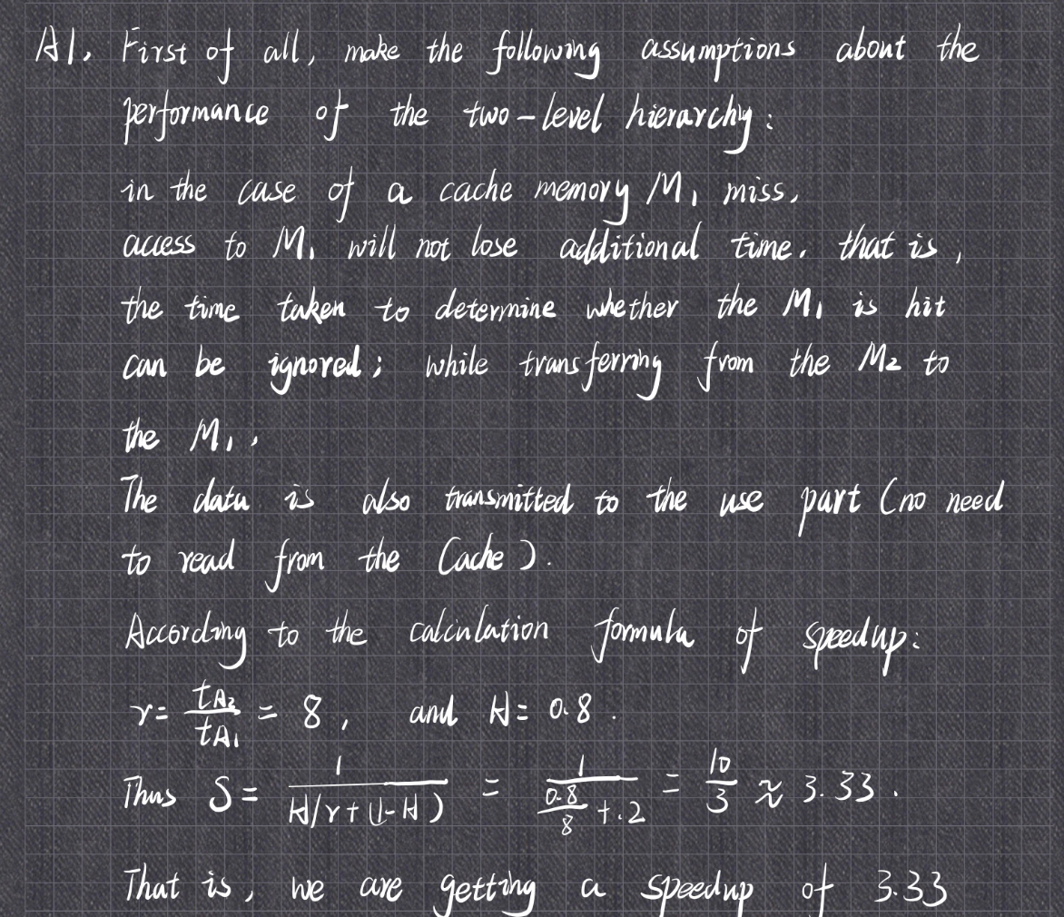

Q2. You are given memory chips of 512M × 8 size. How can you make a memory of size 4G×8 from the given chips?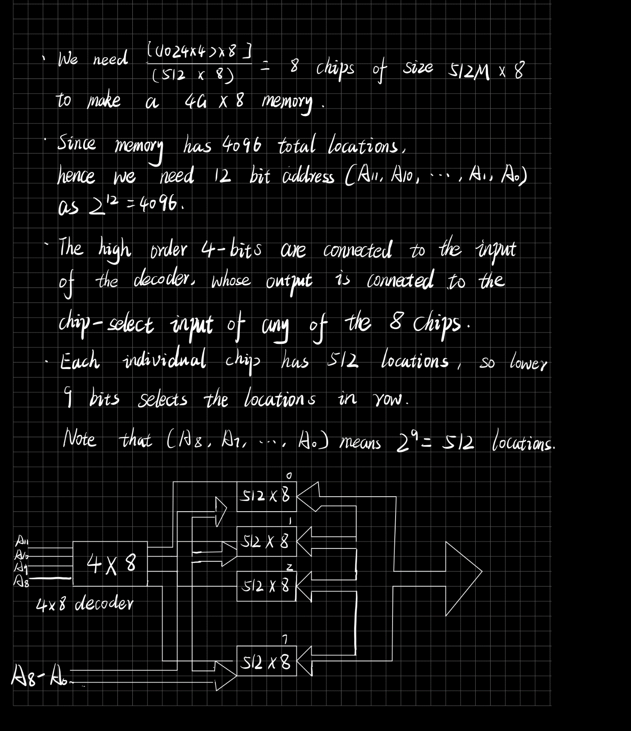

Q3. Consider a case when you have a memory of with 8096 locations. Each location can hold 16-bit word. The CPU wants to fetch the data from the memory location 0x1F54. What will be the binary value for this location’s address? In which CPU register will this address be stored?

A3.It is the binary value for this location’s address: 1111101010100.

This address will be stored in mar CPU register.

Q4. A CPU has a 22 bits wide memory address bus. What size of memory can the CPU support in terms of proper memory units (i.e. Kilo, Mega, Giga, Tera etc.)?

A4. 2^22 = 4194304

**Operating System**

Q5: According to the information and the scenario shown below, **draw lines of the state change of CPU and the state change of I/O devices at the following figure**.

**Scenario**

**Information**

* Without any events, CPU stays in the “user process executing state” and the I/O device stays in the “idle state”.
* The I/O device requires 30ms to transmit I/O request to the CPU.
* In the CPU, the “I/O request A” is executed for 20ms and the “I/O request B” is executed for 40ms.
* When CPU receives an I/O request, it can immediately execute the I/O request.
* There is no delay to change an execution state in both the CPU and the I/O device.

**Scenario**

* the I/O device starts to transmit “the I/O request A” to the CPU at 10ms
* the I/O device starts to transmit “the I/O request B” to the CPU at 100ms

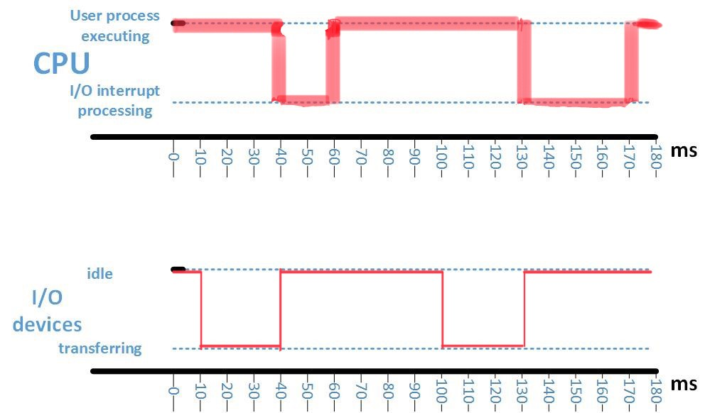

Q6: Because a process is active unit, the current activity of a process is represented by “state”. (1) Describe the basic states of a process and (2) explain each role of the different states

A6:(1), new, running, waiting, ready, terminated.

(2), new: The process is being created;

Running: Instructions are being executed;

Waiting: The process is waiting for some event to occur;

Ready: The process is waiting to be assigned to a processor;

Terminated: The process has finished execution.

Q7: What are the advantages and disadvantages of using a microkernel approach?

Moves as much from the kernel into user space

A7: • Communication takes place between user modules using message passing

1. Advantages

Easier to extend a microkernel ; Easier to port the operating system to new architectures ; More reliable (less code is running in kernel mode); More secure

 2. Disadvantages

 Low efficiency; Small amount of transmission; There is a delay in delivering the message

**Marking Criteria**

|  |  |
| --- | --- |
| Marking Criteria | Percentage of marks per question |
|  |  |
| Correct interpretation of the question | 20% |
| Logical problem solving work flow | 40% |
| Numerically correct solutions | 40% |